Canopy Data Analysis Report
By Ehsan Keikhavani
105665705
Assignment 1

Executive Summary
This report evaluates Canopy's business goals through an analysis of French-language movie data. Canopy aims to curate high-rated French-language content, provide age-appropriate movies, and identify niche genres for original content production. Using a data processing pipeline in Python, the report cleanses and analyzes the dataset to derive insights aligned with these goals. Findings a strong foundation for curating quality movies, while also highlighting gaps in age-appropriate content and opportunities for niche genre development. The report concludes with recommendations to diversify age-rated offerings, promote high-rated movies, and develop original content in underrepresented genres.

- Introduction and Understanding of Data Analysis and Python in this project:

With the rapid growth of online streaming services, Canopy, a boutique streaming platform, seeks to distinguish itself by specializing in French-language films. To establish its identity and build a loyal audience, Canopy’s goals include curating high-rated French films, catering to different age groups, and producing original content in less saturated genres.
This report explores these objectives through data analysis, utilizing a Python-based data pipeline in a Jupyter Notebook to cleanse, transform, and analyze the provided datasets. Working with Python libraries such as Pandas and Matplotlib in Jupyter Notebook provided a robust framework for managing, analyzing, and visualizing data.
The aim is to uncover key patterns and trends to inform Canopy’s content curation and original production strategies. This project illustrated the importance of systematic data cleaning and preparation in ensuring accurate, actionable insights from a dataset. Python's flexibility allows to merge multiple datasets, handle missing values, and perform descriptive and exploratory data analysis efficiently.
This experience magnified the role of data analysis in supporting evidence-based decision-making and showed the value of using data processing pipelines to achieve clarity and reliability in results.

- Approach Used to Create a Data Processing Pipeline:

A structured data processing pipeline in Jupyter Notebook, Using Python's Pandas and Matplotlib libraries to cleanse, transform, and analyze Canopy’s movie data has been developed. Data and Libraries are imported.
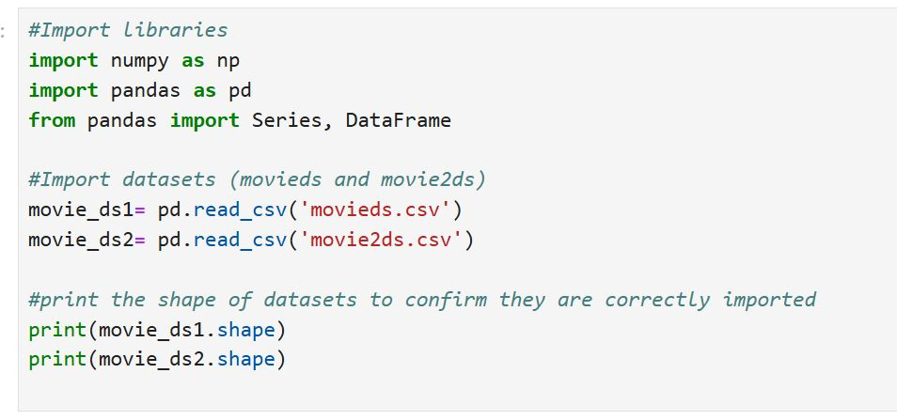

2.1 Data Loading and Initial Inspection

The first task was to load the datasets into Pandas data frames. This required using functions like info () and head() to verify the data structure and identify critical columns for analysis, including Title, Age, IMDb, Genres, and Language. This inspection revealed the need for merging two datasets, each containing distinct information about the movie.

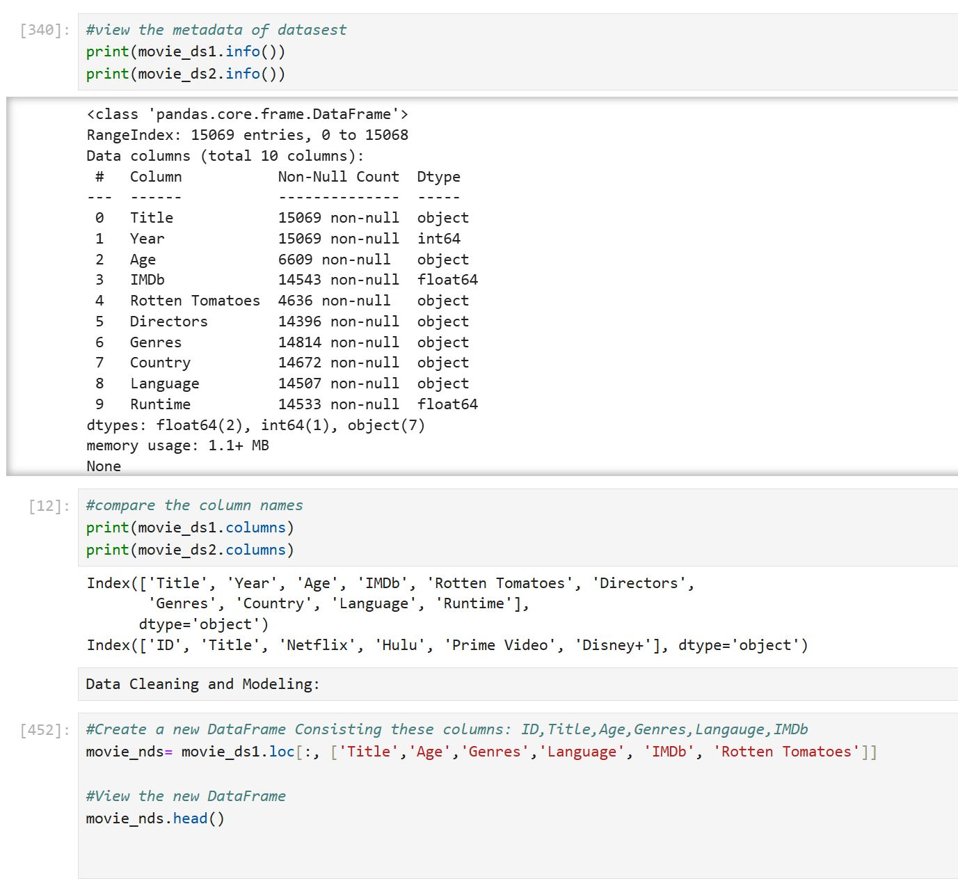

2.2 Merging Datasets

Both datasets were merged using the Title column as a Primary key, to combine all the movie attributes in one Data Frame.
This merger allowed a analysis on quality ratings across the same set of movies, directly supporting Canopy's goals of understanding genre popularity, curating high-quality content, and identifying potential gaps in age-appropriate offerings. By using an inner join, the merged data frame ensured that only entries with complete information from both datasets were analyzed, maintaining data integrity and focus.

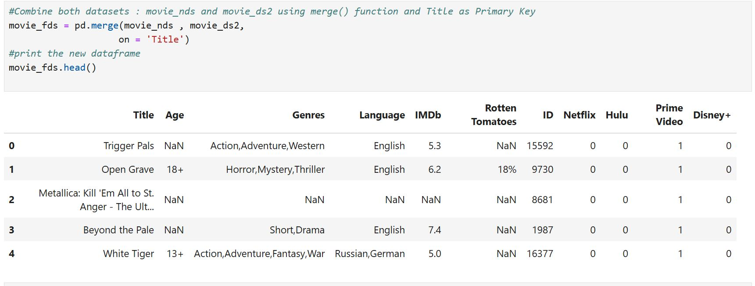

  - Data Cleaning and Handling Missing Values

After the merger, data cleansing focused on addressing missing and inconsistent values across critical columns such as Age, Genres, IMDb, Language.
Key transformations included filtering for French-language content, handling missing data, and duplicates and later standardizing genre entries for easier categorization. The processed dataset contained 638 French-language movies, forming the basis for analyses.
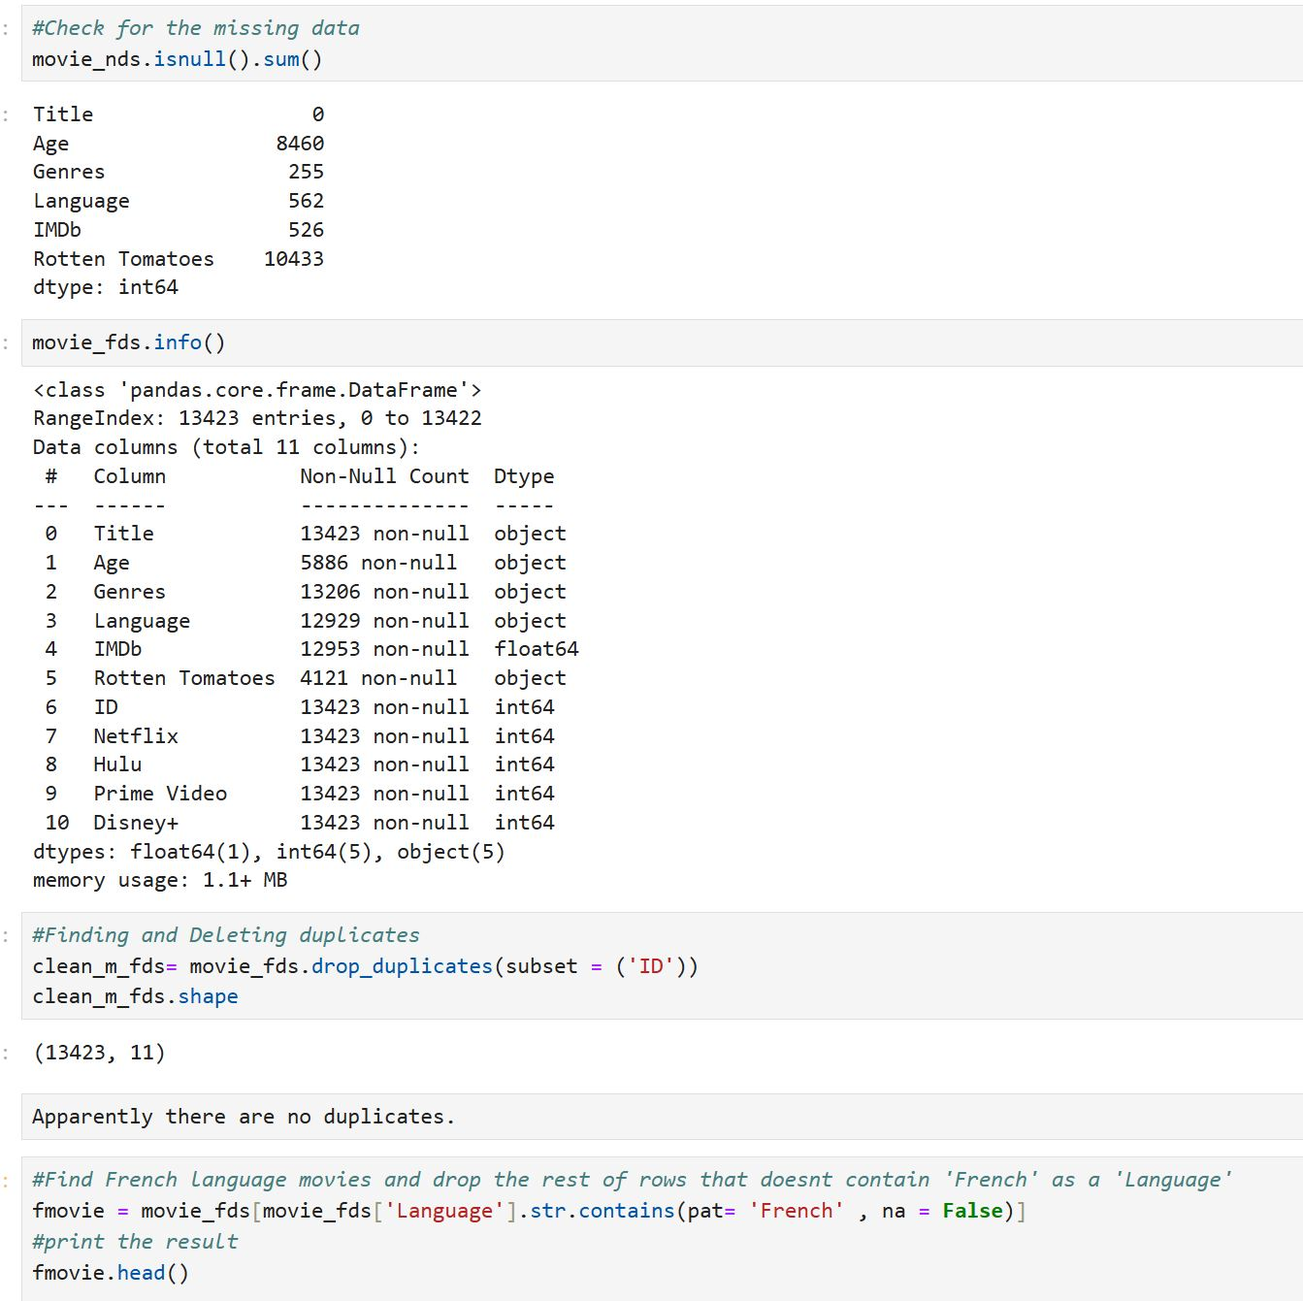

2.4 Data Description

A new dataset Created from the merged datasets consists of essential columns and specifically for French Language movies. Furthermore, calculating summary statistics. This processed dataset was then exported to ensure ease of access for future reference and further analysis.

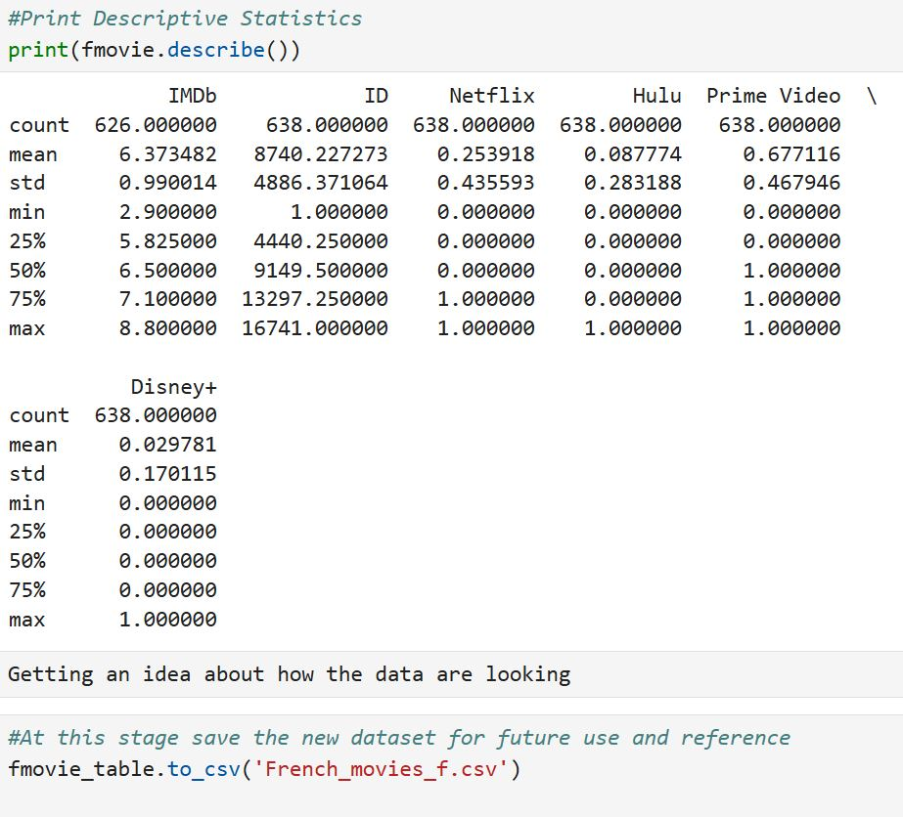

2.5 Data Transformation
To enable more detailed analysis of genres, entries in the Genres column that contained multiple categories were separated by splitting and counting each genre individually. This transformation allowed for an accurate calculation of genre repetition, highlighting the most available and underrepresented genres .
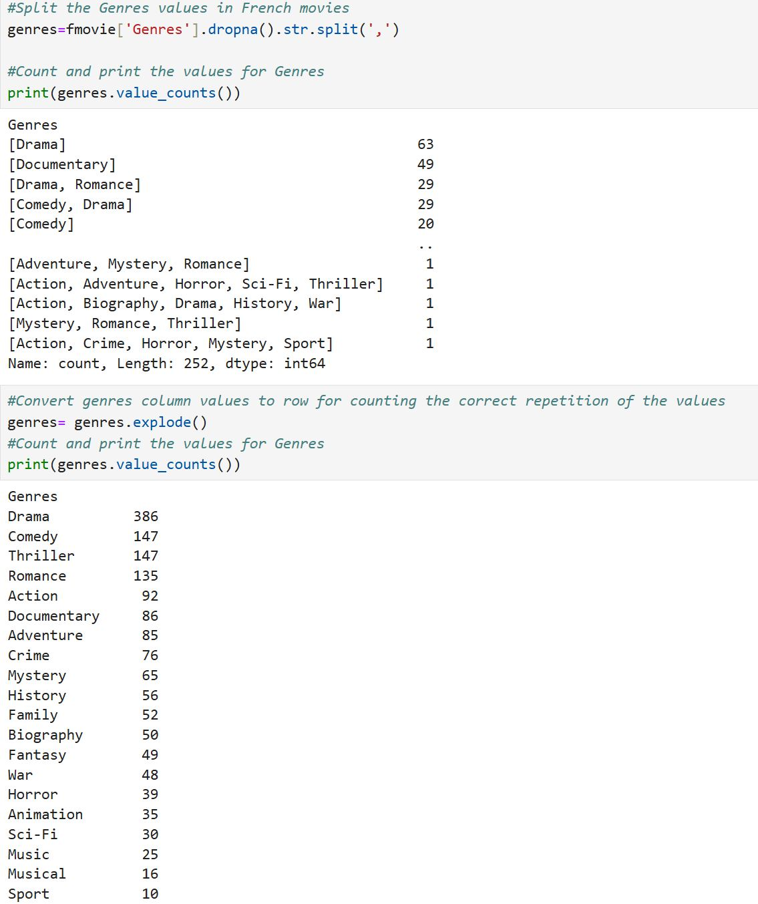

2.6 Data Aggregation and Grouping
Aggregation techniques, such as grouping by genre and age category, allowed for focused analysis of movie quality and demographic suitability. By grouping movies by Genres and calculating average IMDb scores, high-rated Genres and additionally, age categorization analysis.
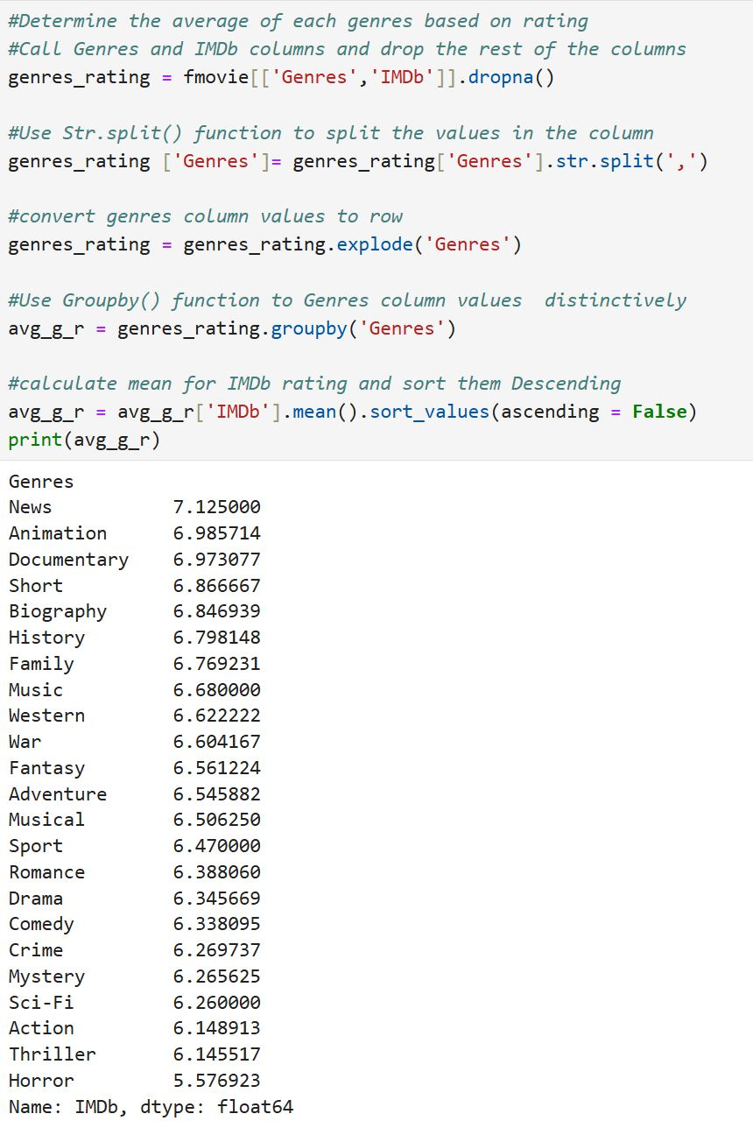

  - Final Data Output and Communication

- Based on ‘IMDb’ and ‘Rotten Tomatoes’ score to reveal the top-rated French Language movie. ‘Inception’ (8.8), ‘It’s a Wonderful Life’ (8.6) and ‘The Green Mile’ (8.6) were the top 3.
- The bottom 3 movies were, ‘Anneliese: The Exorcist Tapes’ (2.9), ‘My Little Sister’ (3.1) and ‘Hold Your Breath’(3.2). Finally, the result was exported as a new dataset.
- Genre: Drama, Comedy, and Thriller were the most common genres, while News, Short and Western films were minimally represented.
- IMDb Ratings by Genre: Genres with the highest average IMDb ratings included News (7.12), Animation (6.98), and Documentary (6.97).
- IMDb Ratings: The average IMDb rating for French-language content was 6.37, with a median of 6.5. This suggests that the collection contains a mix of moderately well-received films.
- Current Age Ratings: The data revealed a predominance of 18+ films, while categories for younger audiences (e.g., 16+, all) were relatively limited.

Final data outputs exported as CSV file for the final step which is communication.

- Conclusions

By addressing the following gaps, Canopy can better fulfill its objectives of being a versatile platform for French-language film lovers while also standing out with unique, original offerings.
“In the U.S. alone, revenue from video-on-demand services was approximately $70 billion in 2023, highlighting the critical role of streaming in daily life “. (Statista, 2023)

  - Curating High-Rated Content: Canopy has a strong foundation in high-rated French-language movies, particularly in genres like News, Animation, and Documentary with IMDb rating above average 7.0. These genres offer promising content for curation and promotion.

  - Providing Content to All Age Groups: The current dominance of 18+ movies limits accessibility for younger audiences, this imbalance could limit Canopy’s appeal to a broader demographic, including families and younger viewers. Revealing an area for strategic improvement.

  - Niche Content Development: Underrepresented genres such as News and Short films. The data shows that these genres are minimally available in the existing French-language content, suggesting an untapped market for niche films that appeal to specific interests. Collaborating with emerging filmmakers or promoting new works in these genres would enable Canopy to cater to unique viewer preferences, creating a distinct platform identity in the competitive streaming industry

4. Recommendations

  - Diversify Age-Rated Content:
  - To attract a wider demographic, particularly families and young viewers, Canopy should expand its catalog of family-friendly movies and content suitable for teenagers. This could include collaborations with filmmakers focused on younger audiences or acquisitions of classic French family films.

4.2 Focus on Popular and High-Rated Genres:
  - Emphasizing genres with higher IMDb ratings, such as News, Animation, and Documentary, will allow Canopy to deliver quality content that appeals to viewers. Curating playlists and featured sections for these genres can help Canopy position itself as a source for premium French-language films. (Statista, 2023).

4.3 Invest in Original Content for Niche Genres:
  - Canopy could explore original productions in underrepresented genres like Western, News, and Short Films, which currently lack substantial offerings. Collaborations with emerging filmmakers in these areas can provide Canopy with unique content that differentiates it from larger streaming platforms. (Screen Daily ,2021)

4.4 Develop Data-Driven Curation Strategies:
  - By using data analytics to continually track genre popularity and audience preferences, Canopy can adapt its content offerings over time, refining its selections based on viewer trends.
“The video streaming market is expected to maintain this growth trend, with a projected compound annual growth rate (CAGR) of 21.5% from 2024 to 2030, emphasizing the importance of data-driven strategies in the industry.” (Grand View Research, 2023)

5. References

Grand View Research. (2023). Video streaming market size, share & trends analysis report by solution (Internet Protocol TV, Over-the-top), by platform (gaming consoles, laptops & desktops), by region, and segment forecasts, 2024 - 2030. Retrieved from https://www.grandviewresearch.com/industry-analysis/video-streaming-market

Screen Daily. (2021). The rise of niche streaming platforms: A case study. ScreenDaily.com. Retrieved from https://www.screendaily.com

Statista. (2023). Video streaming worldwide - Statistics & Facts. Retrieved from https://www.statista.com/topics/7527/video-streaming-worldwide/

